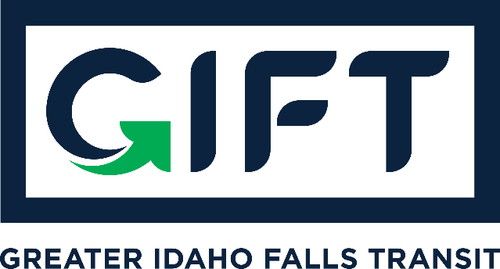

dba TRPTA TARGHEE REGIONAL PUBLIC TRANSPROTATION AUTHORITY
PHONE: 208-612-8323

BOARD MEMBERS:
Michelle Ziel-Dingman, Lisa Farris, Arnold Cantu, and Rick Cloutier
ABSENT: Michael Walker
Tuesday, October 19, 2021
10:00 am – 11:00 am
Idaho Falls City Annex Building – Council Chambers

Agenda:
Approval of Minutes from June 15, 2021 GIFT Board Meeting
Approval for Board Chair to Execute Memorandum of Understanding for 2-Year Pilot Project.
- Discussed content of MOU and went over roles and responsibilities as listed.
- The GIFT Board will act in an advisory capacity and will be granted monthly updates about the project by all parties throughout the first year of implementation. After the first year, updates will be required quarterly.
- The GIFT Board will convene public hearings regarding transit, as required under federal transit law.
- The GIFT Board will consider and advise on matters such as fares, performance measures, and other customer-facing policies surrounding the project.
- The GIFT Board will be the entity to which customer service complaints and claims are elevated in the event that they are not resolved by vendor or City of Idaho Falls staff.
Financial update from Treasurer.
- Zoom for $14.99 is our only expense.
- Motion to approve by Michelle Ziel-Dingman and seconded by Rick Cloutier. Unanimously approved.
Action Items:
Approve Minutes from June 15, 2021 GIFT Board Meeting.
- Arnold Cantu (1st motion) and seconded by Lisa Farris. Unanimously approved.
Approve Board Chair to Execute Memorandum of Understanding for 2-Year Pilot Project.
- Lisa Farris (1st motion) and seconded by Rick Cloutier. Unanimously approved.

Other Items:

