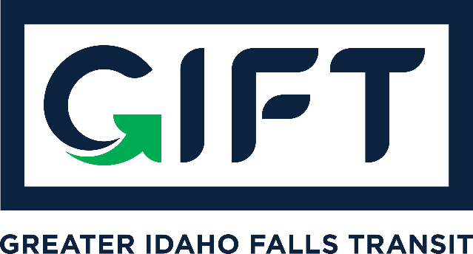

dba TRPTA TARGHEE REGIONAL PUBLIC TRANSPROTATION AUTHORITY
PHONE: 208-612-8323

March 16, 2021 - GIFT Board Meeting Minutes
10:00 am - 11:00 am - Idaho Falls City Annex Building - Small Conference Room

BOARD MEMBERS PRESENT:
Michelle Ziel-Dingman, Lisa Farris, Arnold Cantu, Rick Cloutier, and Michael Walker
EX-OFFICIO BOARD MEMBERS PRESENT: Summer Hirschfield
GUESTS: DaNiel Jose (BMPO)
Minutes:
- Sale of Property:
- 3/2/21 property sold for $1.5 million with 1st American Title. $700,000 more than initial offer.
- Michelle /Lisa to close the old TRPTA account, withdraw funds, and provide to
First American Title Co. within the next 24 hours. We get to keep $10,000 for future service.
- Bankruptcy:
- Hearing took place 3/1/21 via zoom. ITD, FTA, Bank of Commerce, and PERSI participated.
- ITD/FTA took issue believing they had more investment from their entities.
- BOC took issue with $20,000 for seed money to help stand up new transit.
- Michelle offered to reduce the seed amount to $10,000 and all parties agreed.
- 14 days were given to allow comment from creditors.
- Comment period ended at 8:00 am 3/16/21. No comments made.
- Judge to sign off Bankruptcy Plan/Action as early as 3/17/21.
- First American Title Co. will hold and distribute funds to the creditors.
- Funds may be distributed by First American Title Co. as early as 3/19/21.
- Survey Results:
- Partial data, additional aggregating to be completed.
- 200 respondents.
- Order of importance ranked as: Grocery/errands, Medical appts., Recreation, and Work.
- $2.00 each way considered affordable.
- Age of respondents was equally split between ages 51-65 and 31-40.
- Homeowners were biggest responders with renters close behind (MZD will confirm and report next month).
- <$25,000 income represented the majority of respondents.
- CUSP Committee doing a transit and housing survey and asked for our participation and if we could reopen survey so they may send out paper surveys.
- Many survey responders never used TRPTA.
- Michelle and Board willing to reopen and have CUSP send out the paper surveys.
- Mike suggested surveys include an incentive or giveaway of some kind.

Presentation ITD - Summer Hirschfield: Note - Micro-transit is not a fixed route service, but on-demand like Uber and Lyft where riders are picked up at a fixed location.
- Shared case studies from smaller cities that have/are in the process of piloting the micro-transit concept as a bridge to fixed route transit. Case studies to be doc shared with Board members include cities with 60,000 population as with Wilson, NC and Burlington, VT.
- Burlington shared their RFP and job description with Summer.
- Regarding paratransit application/process - No application, has a voucher system, and training process for the intake process. Rider calls and requests specific transit and the appropriate vehicle is dispatched to caller/requester.
- Funding and collection have a process.
- Boise and (2) other cities launched their pilot programs. Boise launched in January and didn’t get the response they anticipated. Likely due to the pandemic and the difference in cities/cultures.
Next Phase:
- Launch pilot program mid-July early Aug.
- April 6-8: (ITD) Ron and Summer will be in Idaho Falls to visit with all stakeholders.
- Summer to work with the Board in identifying stakeholders to visit
- ITD hired new contractor for public transit called WTI (better than last).
- Fees are paid out of ITD Admin budgeted funds
- Finance update by Lisa:
  - Deposit of $369.41 for credit from Intermountain Gas account and final billing.
  - $876.21 output for (3) final Idaho Falls Power bills (table attached).
  - Account balance for old TRPTA account/9194 was $224,713.08 as of 3/16/21.
Action Items Taken: Approval of minutes from Jan 19,2021 meeting
Motion made by Lisa Farris to approve minutes as presented, second by Arnold Cantu, all were in favor.
Next Meeting: April 20, 2020 10:00 am - 11:00 am - Idaho Falls City Annex Bldg. Small Conference room.

