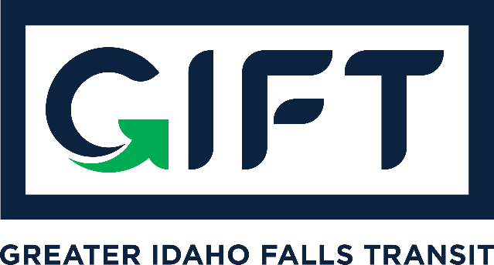

dba TRPTA TARGHEE REGIONAL PUBLIC TRANSPROTATION AUTHORITY
PHONE: 208-612-8323

BOARD MEETING
Tuesday January 19, 2021
9:00 am - 10:00 am - Idaho Falls City Annex Building - Small Conference Room

BOARD MEMBERS PRESENT:
Michelle Ziel-Dingman and Lisa Farris
Arnold Cantu had technical challenges due to Zoom

EX-OFFICIO BOARD MEMBERS PRESENT:
Summer Hirschfield and Darrell West

GUESTS:
DaNiel Jose (BMPO) and Brad Cramer (City of Idaho Falls)
Agenda:
- Presentation ITD - Summer Hirschfield (NO ACTION TAKEN);
  - Received information only on micro-transit concepts that have worked well in other cities.
  - This is not a fixed route service, but on-demand like Uber and Lyft where riders are picked up at a fixed location.
- Introduce new board member, Mike Walker;
  - Absent
- Approval of minutes from Dec. meeting;
  - NO ACTION TAKEN – WILL APPROVE IN FEB. 2021
- Bankruptcy update;
  - Court date at the end of February 2020. Michelle will provide more details when she knows more.
  - Two claims made as part of our bankruptcy from ITD and FTA.
- Finance update;
  - Deposited $40,000 into regular account from purchase extension fees (from property buyer Alban Hatch). Waiting to see if they extend again and will collect more fees.
- Survey update.
  - Survey going out today unless there are issues.
Action Items:
Approve minutes from 12/15/20 meeting;
  - NO ACTION TAKEN
Possible Action - Regarding presentation by Summer Hirchfield.
  - NO ACTION TAKEN

Other items:

Next Meeting: February 16, 2020 10:00 am - 11:00 am - Idaho Falls City Annex Building
Small Conference Room

