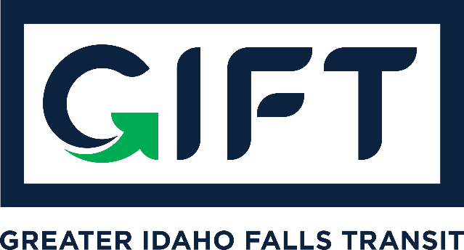

dba TRPTA TARGHEE REGIONAL PUBLIC TRANSPROTATION AUTHORITY
PHONE: 208-612-8323

BOARD MEMBERS:
Michelle Ziel-Dingman, Lisa Farris, Arnold Cantu, Rick Cloutier, and Michael Walker
BOARD MEETING
Tuesday, June 15th, 2021
10:00 am – 11:00 am
Idaho Falls City Annex Building – Council Chambers
Agenda:
- Approval of May 25, 2021 GIFT dba TRPTA Board Meeting Minutes.
- Approval of finance report.
- Discussion of whether or not to keep Zoom subscription for out-of-area participation.
- Discussion of Transit Coordinator position and review of job description.
- ITD / Micro-transit plan update.
- GIFT Survey Distribution Update & Ideas.
- CUSP Report Review of Transportation Ideas.

Action Items:
- Approve May 25, 2021 GIFT dba TRPTA Board Meeting Minutes.

Other Items:

