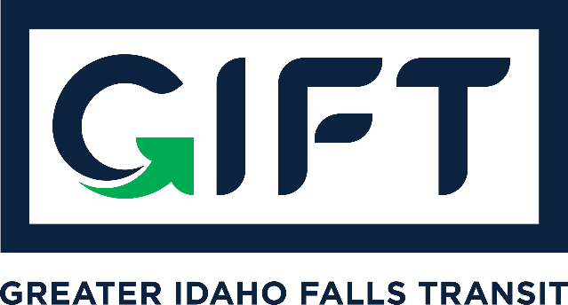

dba TRPTA TARGHEE REGIONAL PUBLIC TRANSPROTATION AUTHORITY
PHONE: 208-612-8323

BOARD MEMBERS:
Michelle Ziel-Dingman, Lisa Farris, Arnold Cantu, Rick Cloutier, and Michael Walker
BOARD MEETING
Wednesday, April 20, 2021
10:00 am – 11:00 am
Idaho Falls City Annex Building – Council Chambers
Agenda:
- Approval of 3-16-21 GIFT dba TRPTA Board Meeting Minutes.
- Bankruptcy update.
- Finance update.
- Survey update.
- Update of ITD support and process moving forward.

Action Items:
- Approve 3-16-21 GIFT dba TRPTA Board Meeting Minutes.
- Approve to temporarily cease GIFT dba TRPTA Board Meetings.

Other Items:

